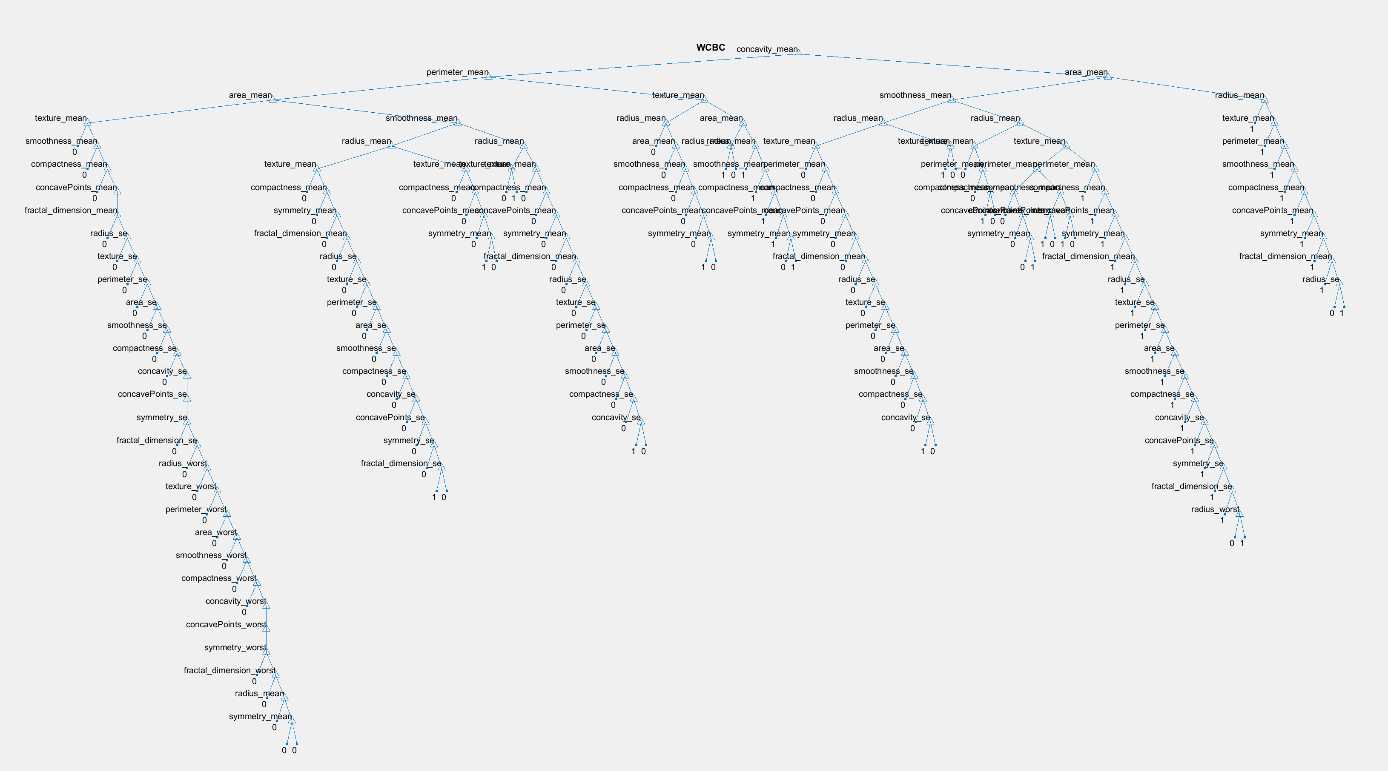

Figure : Classification Decision Tree

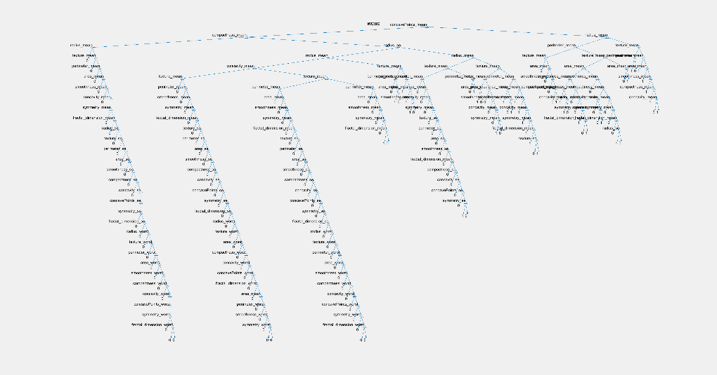**Fold 1:**

Figure : Tree Created During Fold 1

True Positives: 36

False Positives: 0

All Positives: 45

F-Score: 36

True Negatives: 11

False Negatives: 9

All Negatives: 11

F-Score: 14.1935

Overall Accuracy: 83.9286%

**Fold 2:**

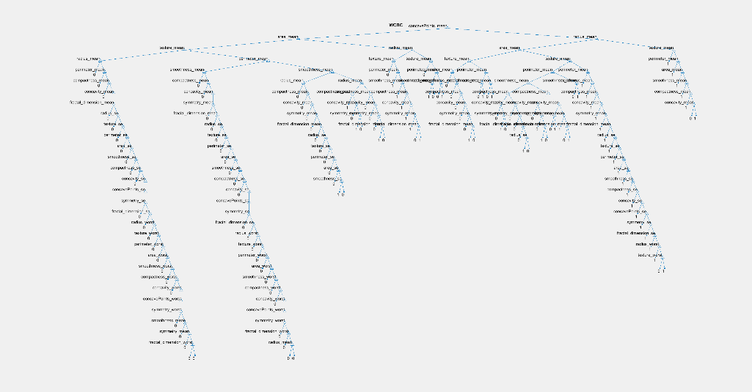True Positives: 22

Figure : Tree Created During Fold 2

False Positives: 2

All Positives: 23

F-Score: 22.9565

True Negatives: 32

False Negatives: 1

All Negatives: 34

F-Score: 32.4923

Overall Accuracy: 94.7368%

**Fold 3:**

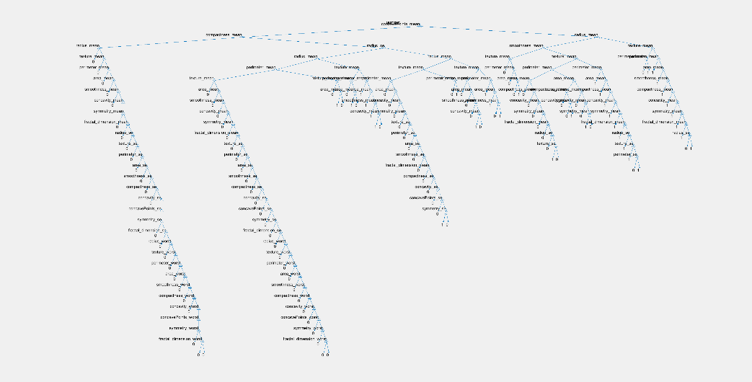True Positives: 15

Figure : Tree Created During Fold 3

False Positives: 4

All Positives: 20

F-Score: 16.7647

True Negatives: 33

False Negatives: 5

All Negatives: 37

F-Score: 35.3239

Overall Accuracy: 84.2105%

**Fold 4:**

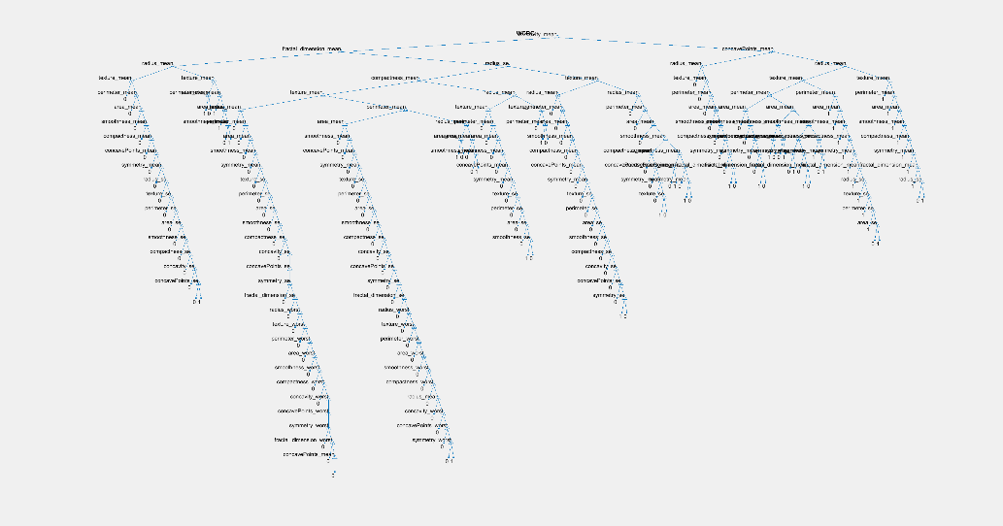True Positives: 22

Figure : Tree Created During Fold 4

False Positives: 1

All Positives: 30

F-Score: 22.4889

True Negatives: 26

False Negatives: 8

All Negatives: 27

F-Score: 29.4667

Overall Accuracy: 84.2105%

**Fold 5:**

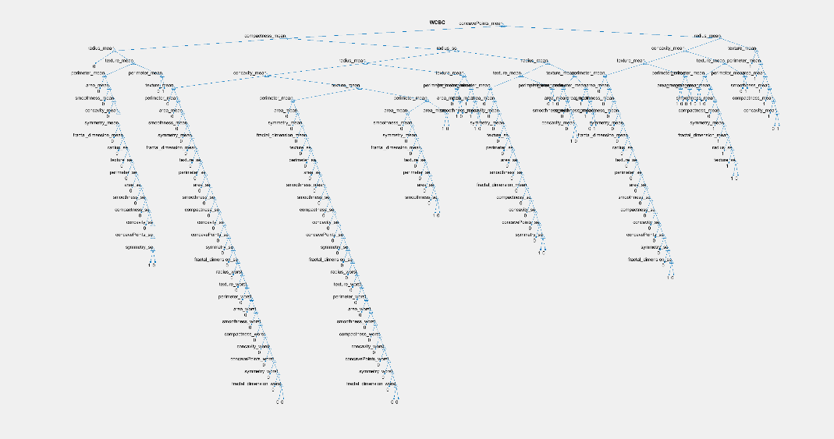True Positives: 25

Figure : Tree Created During Fold 5

False Positives: 1

All Positives: 26

F-Score: 25.4902

True Negatives: 30

False Negatives: 1

All Negatives: 31

F-Score: 30.4918

Overall Accuracy: 96.4912%

**Fold 6:**

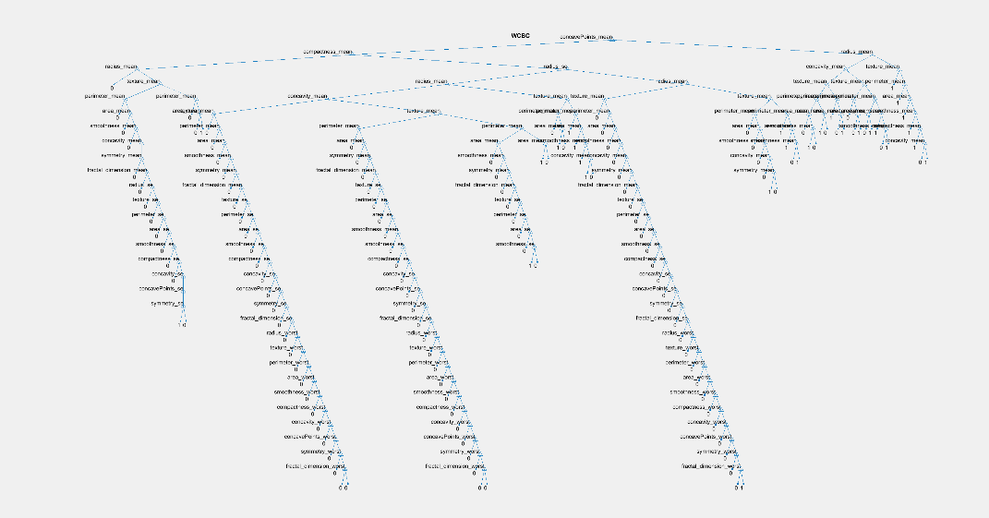True Positives: 12

Figure : Tree Created During Fold 6

False Positives: 1

All Positives: 13

F-Score: 12.4800

True Negatives: 43

False Negatives: 1

All Negatives: 44

F-Score: 43.4943

Overall Accuracy: 96.4912%

**Fold 7:**

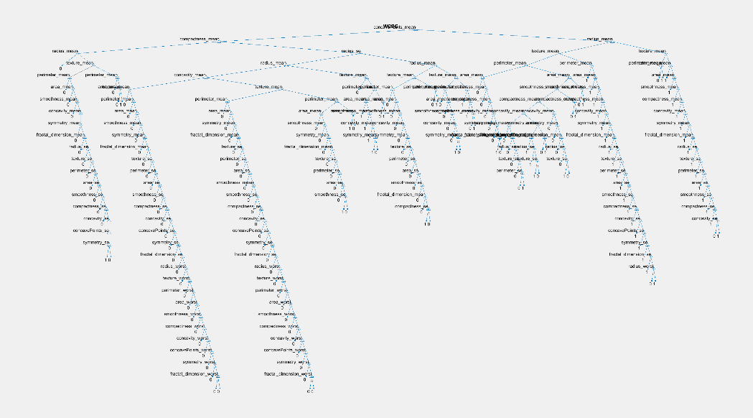True Positives: 17

Figure : Tree Created During Fold 7

False Positives: 4

All Positives: 17

F-Score: 18.7895

True Negatives: 36

False Negatives: 36

All Negatives: 40

F-Score: 36

Overall Accuracy: 92.9825%

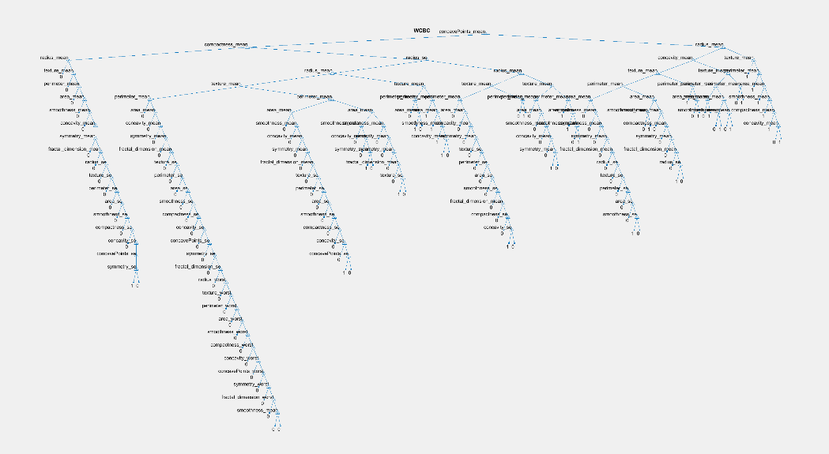**Fold 8:**

Figure : Tree Created During Fold 8

True Positives: 11

False Positives: 1

All Positives: 13

F-Score: 11.4783

True Negatives: 43

False Negatives: 2

All Negatives: 44

F-Score: 43.9773

Overall Accuracy: 94.7368%

**Fold 9:**

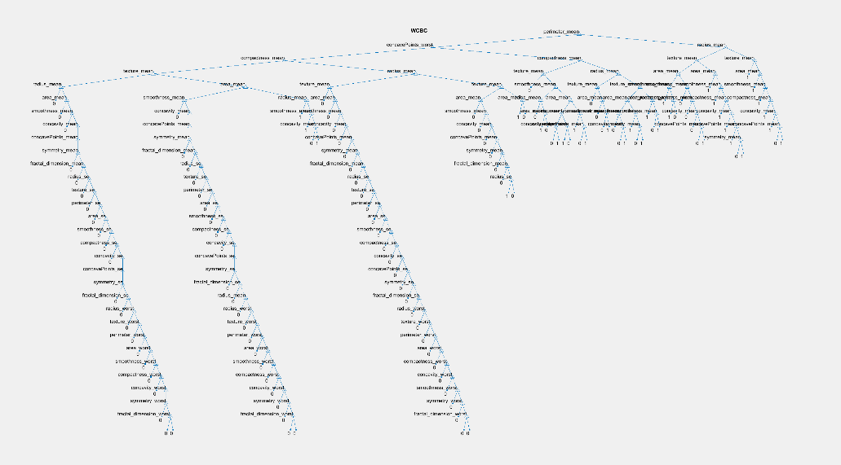True Positives: 13

Figure : Tree Created During Fold 9

False Positives: 8

All Positives: 13

F-Score: 16.0588

True Negatives: 36

False Negatives: 0

All Negatives: 44

F-Score: 36

Overall Accuracy: 85.9649%

**Fold 10:**

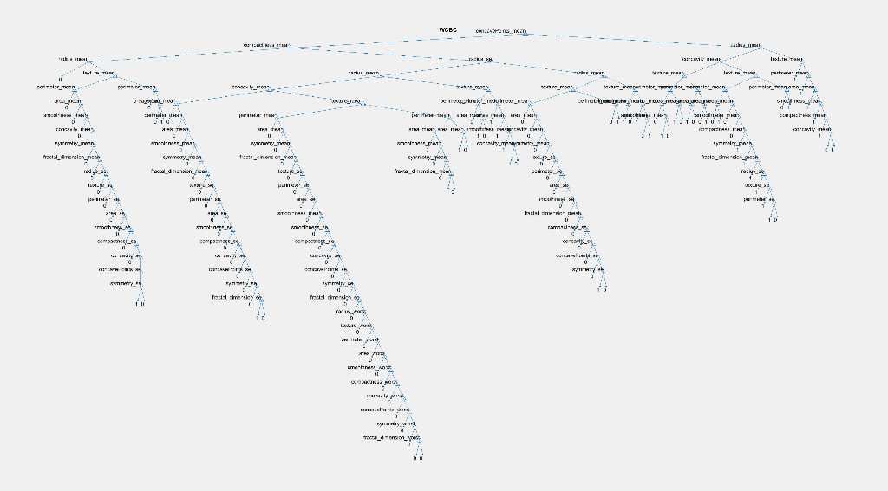True Positives: 9

Figure : Tree Created During Fold 10

False Positives: 2

All Positives: 10

F-Score: 9.9000

True Negatives: 45

False Negatives: 1

All Negatives: 47

F-Score: 45.4945

Overall Accuracy: 94.7368%